GROUP 3 MEMBERS
KOKI KYALO -672612
ROSE CHIYAMWE -673151
JOY MWAURA -672232

1.CORE DECISION PROBLEM
How can the online retail enterprise optimize market investment, customer retention strategies, and inventory allocation across diverse product lines and geographic regions to minimize stockouts and maximize overall revenue?
Context & Challenge:
While the business generates strong overall volume (£16.63M Total Sales) and maintains a substantial active customer base (6K customers), performance is heavily skewed toward a single dominant market (United Kingdom) and top-selling product lines. Additionally, sales volatility and slow-moving product inventory create operational inefficiencies. The primary decision problem is determining how to strategically allocate capital and inventory to protect primary revenue streams while capitalizing on opportunities to increase Average Order Value (£467.07) through target bundling and demand forecasting.

2.DATA ACQUISITION
A real-world retail sales dataset, Online Retail II, was obtained from the UCI Machine Learning Repository. The dataset contains online retail transactions from December 2009 to December 2011, including invoice details, product descriptions, quantities, unit prices, customer IDs, and country information.
The dataset contains well over the required minimum of 5,000 records, making it suitable for the project.

Data columns and types
The Online Retail II dataset contains several columns, with each column representing a different aspect of a retail transaction. Understanding the meaning and data type of each column was important during the data cleaning and transformation process.
Column | What it represents | Example | Data type
Invoice | Unique number identifying a sales transaction or order. | 536365 | Text/Number
StockCode | Unique code identifying a product. | 85123A | Alphanumeric
Description | Name or description of the product sold. | WHITE HANGING HEART T-LIGHT HOLDER | Text
Quantity | Number of units of a product purchased in the transaction. | 6 | Integer (whole number)
InvoiceDate | Date and time when the transaction took place. | 01/12/2010 08:26 | Date/Time
Price | Unit price of one item. | 2.55 | Decimal number
Customer ID | Unique identification number of the customer who made the purchase. | 17850 | Integer/Number
Country | Country where the customer was located. | United Kingdom | Text
Total Sales (created) | Total value of the transaction, calculated as Quantity × Price. | 15.30 | Decimal number

The Total Sales column was not an original column in the dataset. It was created during the data transformation process using the formula Total Sales = Quantity × Price. This column supports sales analysis and helps the Decision Support System evaluate the value of transactions.

3.DATA CLEANING AND TRANSFORMATION
The dataset was provided in two worksheets: Year 2009–2010 and Year 2010–2011. Using Python and the Pandas library in Anaconda Jupyter Notebook, both worksheets were merged into a single dataset to create one complete retail sales database for analysis.
Merged the two yearly datasets into one dataset.
Removed records with missing customer IDs.
Removed records with missing product descriptions.
Removed cancelled transactions (invoice numbers beginning with 'C').
Removed duplicate records.
Removed transactions with invalid quantities or unit prices.
Created a new calculated column called Total Sales using the formula: Total Sales = Quantity × Unit Price.
Tools Used
Python
Pandas
Anaconda Jupyter Notebook
Microsoft Excel
GitHub Desktop
GitHub

4. DECISION MODEL AND ANALYTICAL COMPONENT
The following are the metrics used to drive the decision model;
PRICING METRICS
- Total sales: calculates the total revenue generated
FORMULA: Total Sales Measure = SUM('Sheet1'[Total Sales])
- Average Order Value: calculates the average amount spent per transaction
FORMULA: Average Order Value = DIVIDE([Total Sales Measure], DISTINCTCOUNT('Sheet1'[Invoice]))

INVENTORY METRICS
- Total items sold: measures the total volume of products moving out of inventory at a given time
FORMULA: Total Items Sold = SUM('Sheet1'[Quantity])
- Average basket size: measures the average number of physical items a customer places in their cart per checkout invoice
FORMULA: Average Basket Size = DIVIDE(SUM('Sheet1'[Quantity]), DISTINCTCOUNT('Sheet1'[Invoice]))

PRODUCT ANALYSIS
- Active customer count: calculates the total number of unique customer ID’s present in the data set
FORMULA: Active Customer Count = DISTINCTCOUNT(SalesData[CustomerID])
- Purchase frequency per customer: calculates how many unique orders the average active customer places
FORMULA: Purchase Frequency = DIVIDE(DISTINCTCOUNT('Sheet1'[Invoice]), [Active Customer Count])

5. DASHBOARDS

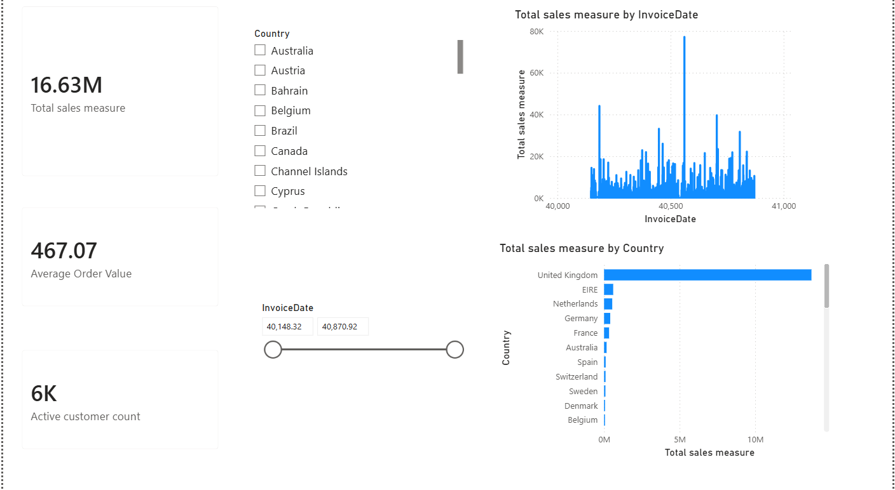

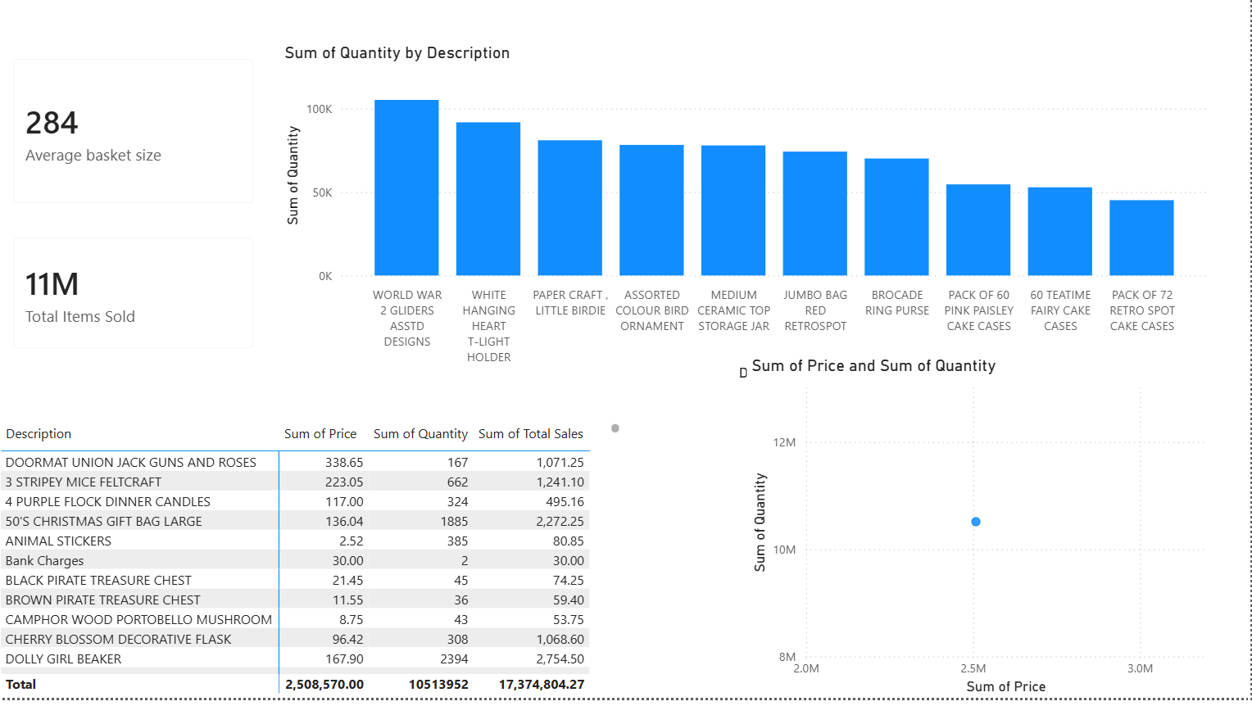

VISUAL COMPONENTS
PAGE 1 (7 dashboards)
KPI CARDS(3)
- Total sales measure
- Average Order Value
- Active customer count

Interactive slicers (2)
- Country
- Invoice date

Charts (2)
- Line chart
- Clustered bar chart

PAGE 2 (5 dashboards)
Inventory KPI’s (2)
- Total items sold
- Average basket size

Deep dive charts (3)
- Clustered column chart
- Scatter plot
- Matrix

INTERACTIVE FEATURES
- Global Filters & Slicers: Explain that the Country checkbox slicer and the InvoiceDate timeline slider act as global controllers for the entire page. Adjusting these components dynamically updates all other charts simultaneously.
- KPI Card Responses: When a user selects a specific region (e.g., selecting Australia or Germany), the core high-level metrics, Total Sales Measure, Average Order Value, and Active Customer Count recalculate instantly to reflect only that selection.
- Time-Series Tracking: The Total sales measure by InvoiceDate line chart adjusts its horizontal boundaries based on the InvoiceDate slider, enabling users to isolate macroeconomic anomalies or peak holiday sales periods.
- Cross-Filtering Capabilities: Emphasize that clicking on a specific bar in the Total sales measure by Country chart (e.g., clicking the massive bar for the United Kingdom) automatically acts as a temporary filter, cross-highlighting the line chart to show the exact sales trajectory for just that country.
- Top-Performing Product Isolation: The Sum of Quantity by Description bar chart highlights your highest-volume items (like "WORLD WAR 2 GLIDERS ASSTD DESIGNS"). Clicking on any individual bar will instantly filter the bottom table down to only show that specific item's pricing data, unit totals, and financial yields.
- Granular Table Interactions: The detailed matrix view at the bottom left tracks Sum of Price, Sum of Quantity, and Sum of Total Sales across your stock-keeping units. Decision-makers can sort columns hierarchically to instantly identify anomalies, such as high-priced items with low quantity versus low-priced items driving high volume.
- Volume vs. Price Correlation (Scatter Plot): The Sum of Price and Sum of Quantity scatter plot maps your entire product catalog out across price elasticity. Clicking a row in the product table flags that specific coordinate point on the scatter plot, allowing management to see visually where a product sits in terms of market value vs. operational demand.

6. BUSINESS RECOMMENDATIONS

Five recommendations were developed as part of the Decision Output Framework. These recommendations focus on key areas of retail decision-making, including market investment, inventory management, demand planning, product portfolio management, and revenue enhancement.
Two recommendations were classified as High Priority, reflecting their potential impact on revenue protection and operational performance.
The first high-priority recommendation focuses on the United Kingdom market, which generates the highest sales. The recommended decision is to increase UK marketing and inventory investment. Maintaining adequate inventory levels and continuing to support marketing activities in the strongest-performing market can help protect the organization's primary revenue source and support continued growth.
The second high-priority recommendation addresses top-performing products that consistently record high sales volumes. The recommended decision is to restock these products before inventory levels become critically low. This action aims to reduce the risk of stockouts and prevent potential lost sales resulting from insufficient product availability.
The remaining three recommendations were classified as Medium Priority and focus on opportunities for operational improvement and revenue growth.
The first medium-priority recommendation addresses fluctuations in sales across different periods. The recommended decision is to forecast demand and improve inventory planning. This can enable the organization to better prepare for changes in demand and optimize inventory levels.
The second medium-priority recommendation concerns the presence of low-selling products. The recommended decision is to discount, bundle, or discontinue consistently under-performing products, depending on their strategic importance. This approach can help improve inventory efficiency and reduce resources allocated to products with limited demand.
The final medium-priority recommendation focuses on the Average Order Value of £469.98. This presents an opportunity to increase revenue generated from individual transactions. The recommended decision is to introduce cross-selling strategies and product bundles to encourage customers to purchase additional or complementary products.

The five recommendations are summarized below:
Priority | Insight | Business Impact | Recommended Decision
High | The United Kingdom generates the highest sales. | The UK represents the organization's strongest revenue-generating market. | Increase UK marketing investment and maintain adequate inventory levels to support continued growth.
High | Top-performing products consistently record high sales volumes. | High demand may increase the risk of stock shortages and lost sales. | Prioritize restocking before inventory levels become critically low.
Medium | Sales fluctuate across different periods. | Poor demand planning may result in stock shortages or excess inventory. | Forecast demand and improve inventory planning using historical sales patterns.
Medium | Low-selling products are present within the product portfolio. | Slow-moving inventory may reduce inventory efficiency and tie up resources. | Discount, bundle, or discontinue consistently under-performing products where appropriate.
Medium | Average Order Value is £469.98. | There is an opportunity to increase revenue generated per customer transaction. | Introduce cross-selling strategies and product bundles to increase customer spending.

Framework Structure and Functionality
The Decision Output Framework follows a structured decision-making process:
Insight → Business Impact → Recommended Decision → Priority
This process ensures that each recommendation is based on an identified finding, supported by a clear business rationale, and assigned an appropriate level of priority.
The framework consists of two Power BI pages.
Decision Overview
The Decision Overview page provides an executive-level summary of the recommendations generated by the DSS. The page uses KPI cards to display the total number of recommendations and their distribution according to priority.
The framework contains five recommendations in total, consisting of:
- 2 High-priority recommendations
- 3 Medium-priority recommendations
A priority slicer is also included, allowing decision-makers to filter the recommendations according to their priority level. This functionality enables users to focus on the most urgent actions or review recommendations according to specific levels of importance.
Decision Recommendations
The Decision Recommendations page presents the detailed decision output in the form of a structured decision matrix. The matrix connects each identified insight to its associated business impact and recommended managerial action.
The framework uses priority indicators to distinguish between high- and medium-priority recommendations. This provides decision-makers with an immediate understanding of which actions require greater attention.
The decision matrix is structured around four key elements:
- Insight – identifies the finding that requires managerial attention.
- Business Impact – explains why the finding is relevant to the organization.
- Recommended Decision – specifies the action that management should consider taking.
- Priority – indicates the relative urgency of the recommended action.
This structure provides a clear and traceable link between analytical findings and managerial decisions.

strategic Importance and Business Impact
The Decision Output Framework is an essential component of the Retail Sales Decision Support System because it transforms analytical findings into practical managerial guidance. Rather than presenting decision-makers with information alone, the framework provides specific recommendations regarding how the organization can respond to identified business conditions.
The prioritization system further supports managerial decision-making by directing attention and resources towards actions with potentially greater business impact. The two high-priority recommendations focus on protecting key revenue sources and ensuring the availability of high-demand products. The three medium-priority recommendations address opportunities related to demand planning, inventory efficiency, and revenue growth.
Based on the analysis and decision model, implementation of the recommended strategies is estimated to have the potential to generate approximately £3.2 million in additional revenue. This projected impact demonstrates the potential value of translating analytical insights into targeted managerial actions.
The estimated revenue enhancement is associated with strategies focused on strengthening high-performing markets, reducing potential lost sales caused by stock shortages, improving inventory efficiency, and increasing customer spending through cross-selling and product bundling.

6. Integration with the Broader Decision Support System
The Decision Output Framework functions as the prescriptive layer of the broader Retail Sales Decision Support System. It builds directly upon the analytical insights generated by the other components of the Power BI dashboard and transforms these insights into prioritized recommendations.
The framework therefore forms an important stage in the overall decision-making process:
Data → Analysis → Insight → Business Impact → Decision Recommendation → Priority → Management Action
Through this integration, the system provides a clear connection between analytical findings and practical business decisions. The descriptive components of the dashboard provide the information required to understand business performance, while the Decision Output Framework determines how management can respond to the identified insights.
This ensures that the system operates as a cohesive Decision Support System rather than simply functioning as a reporting or data visualization tool.

7. Conclusion
The Decision Output Framework provides the prescriptive analysis layer of the Retail Sales Decision Support System. By translating analytical insights into structured, prioritized, and actionable recommendations, the framework bridges the gap between data analysis and managerial action.
The five recommendations developed address key areas of retail decision-making, including market investment, inventory management, demand forecasting, product portfolio optimisation, and revenue enhancement. The use of priority levels enables decision-makers to distinguish between actions requiring immediate attention and those suitable for medium-term implementation.
The framework therefore strengthens the overall functionality of the Decision Support System by ensuring that analytical findings are not only presented to decision-makers but are also transformed into practical guidance. Through the integration of insights, business impacts, recommended decisions, and priorities, the Decision Output Framework supports more informed and evidence-based managerial decision-making.

7. GITHUB COLLABORATION

Rose
Cloned the project repository.
Created my own branch (rose-data-cleaning).
Uploaded the cleaned dataset.
Uploaded the Python notebook containing the data cleaning code
Made a meaningful commit describing the completed work.
Created a Pull Request for review and merging.
Deliverables
RetailSales_Cleaned.xlsx
Data_cleaning.ipynb

Koki
Created a feature branch (feature\analytics-and-dashboard)
Uploaded data set (retail_sales_visuals)
Created a pull request for review and merging
Reviewed and approved a member's pull request
Made a meaningful commit describing the completed work

Deliverables
Retail_sales_visuals.pbix
Reatail_project_report_docx

Joy mwaura
Created a feature branch (joy-decision-framework)
Cloned the project repository
Created a pull request for review and merging
Reviewed and approved a member’s pull request

Deliverables
Retail_sales_visuals_v1.pbix

